**COMPARISON BETWEEN SELECTION ALGORITHMS & CROSSOVERS**

Mutation: swap_mutation Pop=500 Gens=300 10 runs

**FPS 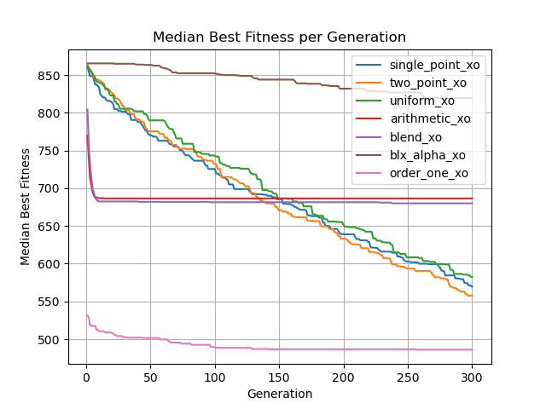 bf=467**

**bf=496 ?**

**bf=33?**

**FPS RANK TOURNAMENT**